**Library Management System – Stanford University**

By-Youvendra Dhaker



**Table of content:**

1. Introduction
2. Business Analysis Core Concept Mode
3. Requirements Classification Schema
4. Identification of Stakeholders
5. Problem Statement
6. Business Objectives
7. As–is and Future Process Map
8. Scope of the library management System using Context Diagram
9. In Scope & Out of Scope Requirements
10. Activity Diagram
11. ER Diagram
12. Use of Wireframes

**Project Task:**

1. Identifying stakeholders – Create a list of stakeholders (as taught in Business Analysis Planning and Monitoring Knowledge Area)
2. Identify the problem statement in this system
3. Identify advantages of the new Library Management System
4. Create as-is and future process map (using flowcharts). You can use any of the popular tools in the market like Microsoft Visio, Lucid Chart, Creately, Pidoco, or Balsamiq
5. As a Business Analyst working on this project, find out the scope of the Library Management System. To find the scope you can use Use Case diagram (UML) or Context diagram
6. Write down the main features that need to be developed
7. Write the in-scope and out-of-scope items for this software
8. Draw a data flow diagram for the system
9. Draw an ER diagram of the system
10. Write out the Business Requirements, both Functional and Nonfunctional Requirements
11. Draw wireframes or mock screens for any 2 of the features namely book record creation and any other feature as deemed fit by the student. (Use the technique prototyping or wireframing that is taught in the training). You can use any of the wireframing tools like Microsoft PowerPoint, Microsoft Word, Balsamiq, Sketch, Adobe XD, Adobe Illustrator, Figma, UXPin, InVision Studio, InVision Freehand, or Moqups

**INTRODUCTION:**

Stanford University wanted a Library Management Software to automate their library’s activities. Using the software one can find books with a click, issue/reissue books quickly, and it will manage all the data efficiently using this system.

As a Business Analysts we need to capture the requirements to create this Library Management System.

Stanford University is a private research university in California. The university was founded in 1885 and as of today, 83 Nobel laureates, 28 Turing Award laureates, and 8 Fields Medalists have been affiliated with Stanford as students, alumni, faculty, or staff.

For the benefits of the students Stanford started its own library in 1885. The library at Stanford was housed in one large room capable of accommodating 100 readers. As the university grew to enroll more than 20,000+ students in a given year the library grew as well. Today the library boasts of having more than 4 million books in it.

**BUSINESS ANALYSIS CORE CONCEPT MODEL (BACCM):**

|  |  |
| --- | --- |
| **Need** | The need is to have online management software, Using that software student can find books with a click, issue/reissue books quickly and will manage all the data efficiently using this system. It also provides immediate and accurate information regarding any type of book, magazine, or research paper, thereby saving a lot of time and efforts. |
| **Change** | Develop the Library Management Software to automate their library’s activities. So that student can perform their library related activity without any delay. |
| **Solution** | The software should be self-explanatory and very user friendly. It will Reduce overheads and increase productivity of library staff  Java tools can be used. |
| **Context** | * Capable of accommodating 100 readers. * 20,000+ students enroll this year in turn need library grew as well. * Lot of time of staff members are wasted in managing the manual library system. * Fine calculation is a tedious and time-consuming affair. * No reports could be generated on books issued due to the manual system. * It is difficult to manage 4 million books present in the library. * Students could deposit the books only in the library timings. |
| **value** | * A system would have considerable time to those employees who use the service * It Improve student engagement in the library. * It will reduce overheads and increase productivity of library staff. * It help to keep Up-to-date records of all books, research papers, magazines, and other materials available in the library * This will reduce the cost. |
| **Stakeholders** | * Domain Subject matter Expert * Tester * Sponsors * Implementation SME * Project manager * Student/Customer * Library staff/head |

**REQUIREMENT CLASSIFICATION SCHEMA (RCS)**

1. **Business Requirements:**
2. On having the library management system Reduce overheads and increase productivity of library staff.
3. This new system will leads to the highly reduction of the cost.
4. Students can filter the latest books, research papers, magazines, and other materials available in the library.
5. It improve the student’s engagement in the library.
6. It will generate dynamic reports for better decision-making.
7. **Stakeholder requirements:**

|  |  |
| --- | --- |
| **Customer/Students** | 1. Students should be able to access the library system online to know the return date and in case they need to reissue the book. 2. Students should be able to access LMS via mobile and web interface. 3. Student should able to access free e-journals and e-books through the software. 4. Students can return books at any time in the RFID enabled book drop box station. 5. Students should receive automated emails from the system 3 days before the return date to avoid late return of books. |
| **Library Head/ In charge** | The library head should be able to provide the following information using LMS –   * Most rental book * Records of issued and unissued materials in the library (management will decide whether to stock them or not) * Amount of fine collected in a day, week, and month. * Number of lost books * Report on total number of books, journals, etc. * Age of books, that is, which books are more than 20 years old. College generally would prefer not to have very old books since new versions come up every few years. |
| **Project Manager** | 1. Prepare the complete build/development plan and send to management. 2. Make sure to complete the project on time as discussed with management. 3. Make sure the functionality proposed by management and stakeholders must be present and in working state. |
| **Sponsors/ Management** | 1. Management act as a sponsors to provide necessary funding and approval for the software development. 2. Use LMS to take necessary decision on availability of important books and books which are on high demand can be made available in large volume and vice-versa. 3. Manpower – Existing manpower can be reduced if the resulting of automation library system is positive. |
| **Implementation SME** | 1. Provide solution design and implementation consultation. 2. Build the solution using Java technology. 3. Perform Quality check in the solution delivered by performing unit test, system integration testing. 4. Cutover activities and post implementation/ Go-Live support under warranty. |
| **Tester** | 1. Perform validation and verification of the solution developed. 2. Student and library staff can be part of beta testing. |

1. **Solution Requirements:**

***Functional Requirement-***

1. Every reading material available shall have a RFID tag on it. The record of the same will be stored in the database. For each reading material record information like author, book name, publisher name, book edition, date and year of publication, cost of the book, and date of purchase of the book.
2. When a student wants a reading material from the library, they will select the material and go to the checkout counter. The library staff will use a RFID reader to capture the details of the book. The student's name is tagged along with the book they borrowed.
3. System will record the issue date and return date of the book.
4. System shall do an automatic calculation of fines in case of delayed return of books.
5. Library staff should be able to search for books on the LMS by search criteria like name of the book or author.
6. Students should be able to access the library system online to know the return date. They should be able to access it via the web or mobile interface.
7. System shall send automated emails to the students 3 days before the return date to avoid late return of books.
8. Access to free e-journals and e-books through the software.
9. Anti-theft detection: RFID readers are placed at the exit gate of the library and the RFID reader tracks books to a range of 2 meters and would trigger the alarm with a loud sound in case anyone tried to pass through the gate with an unissued book.
10. Book drop box stations to be installed outside the library: Students can return books at any time in the RFID enabled book drop box station. Student’s loan is immediately cancelled once the student deposits the book in the drop box.

***Non-Functional Requirement-***

1. Coding should be done using JAVA
2. The screens should be self-explanatory and very user friendly.
3. Highly secure, scalable, and reliable
4. **Transition Requirements:**

Since we are moving from manual process to an automated process there is transaction process involved which must be smooth.

**IDENTIFICATION OF STAKEHOLDERS:**

Done in BACCM.

**PROBLEM DEFINATION AND SOLUTIONS:**

**Problem Definition:**

The current manual management system is not an efficient way of managing the activities of library and books for a university of 20,000+ students.

There are multiple issues faced by the current library staff.

1. Manually managing the library daily, leads to the lot of time wasted.
2. The number of staff needed to manage the library is high leading to the unnecessary manpower allocation and high cost of maintenance.
3. Late book return fine calculation is a tedious and time-consuming task.
4. No reports could be generated on books issued due to the manual system. Hence current state of the library (no. of book issued vs available in library) is unknown.
5. Given the huge volume of 4 million books, it is difficult to manage same in the library.
6. In the current manual system students could deposit the books only in the library timings. Hence no flexibility of returning book.

**Advantage of LMS:**

Advantage of library management systems:

1. It Reduce overheads and increase productivity of library staff by automating the tasks.
2. Cost reduction by automating book management.
3. Up-to-date records of all books, research papers, magazines, and other materials available in the library.
4. It Improve student engagement in the library
5. It will generate dynamic reports for better decision-making for management.

**Existing System:**

Existing library management system is largely manual process. Following are the activities being performed manually-

1. Management of existing books, journals, magazines etc. to be done by library staffs.
2. Searching the books, journals and magazines.
3. Books issued by students in the library
4. Books return by students in the library.
5. Fine calculation by library staff.
6. Reports generate by library staff for management.
7. Review of manual generated report by management is periodic not available on demand.

**AS IS:**

Strenuous process - where maintaining, organizing, and handling of countless books is done manually.

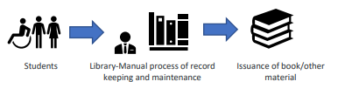

As Is Flow Chart-

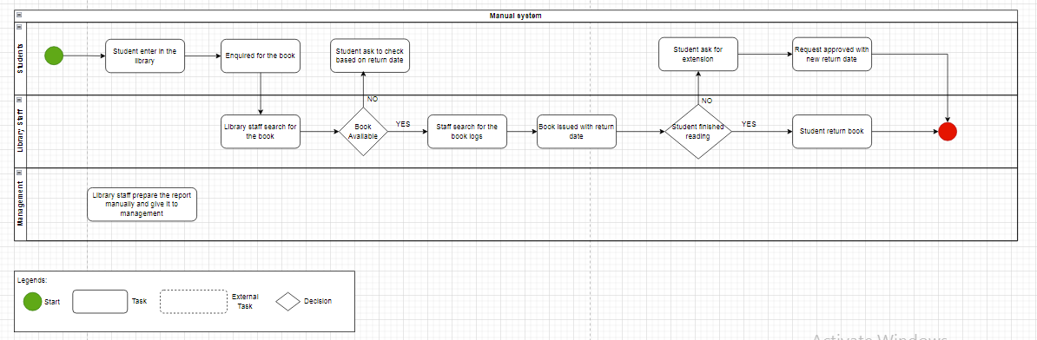

**TO BE:**

Automated Library Management Software to reduce overheads, and improve students engagement.

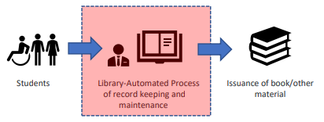

Future process Map Flow Chart-

[create any either Flow chart or ativity diagram]

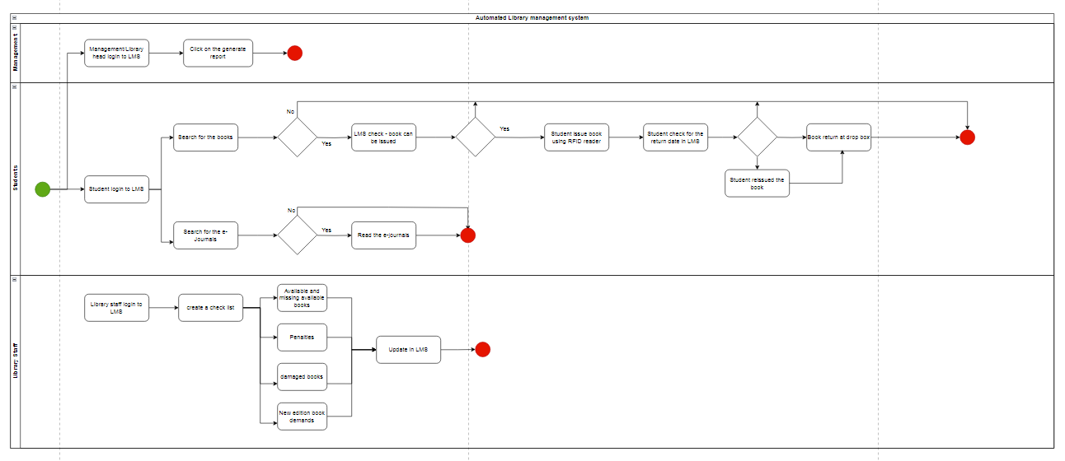

**Scope using Use case diagram:**

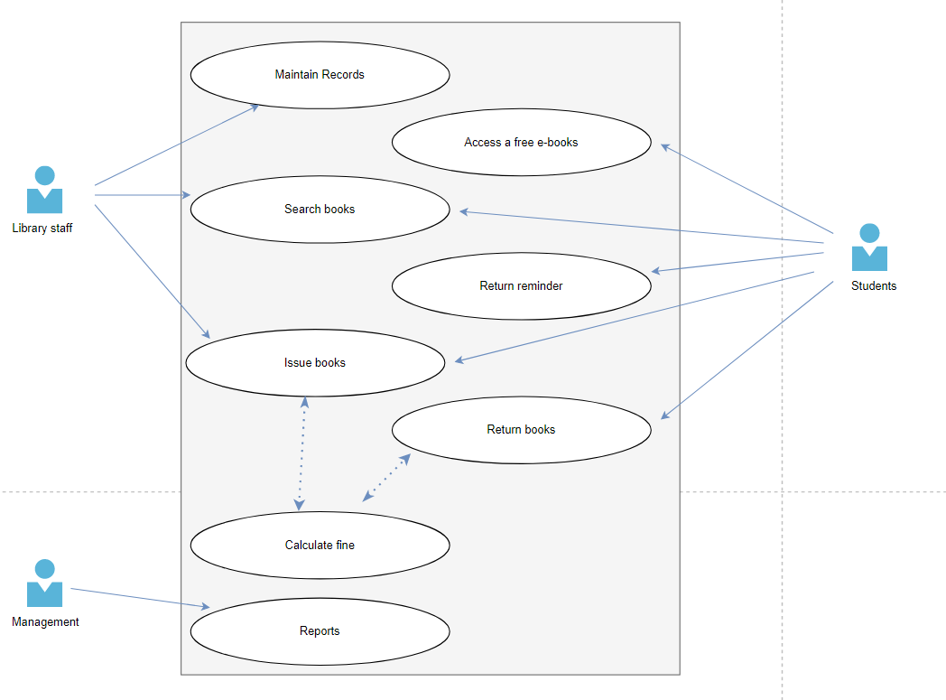

**In scope and out of scope requirements:**

***In scope items:***

* User registration to the system
* Availability status of Books, Magazine, Newspaper, Research papers and Journals.
* Find the books with one click
* Issue/reissue book quickly
* Avoid late return charges
* Generation of the reports
* Record the issue and return date
* Books should be classified subject wise in the system

***Out of scope items:***

* Book supplier notification
* Library staff salary information
* Another student information
* Library manager salary
* Inventory manager salary

**Scope of the library management System using Context Diagram or Data flow diagram**

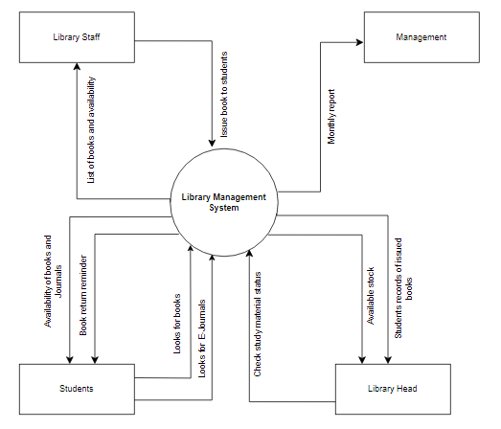

**ER diagram:**

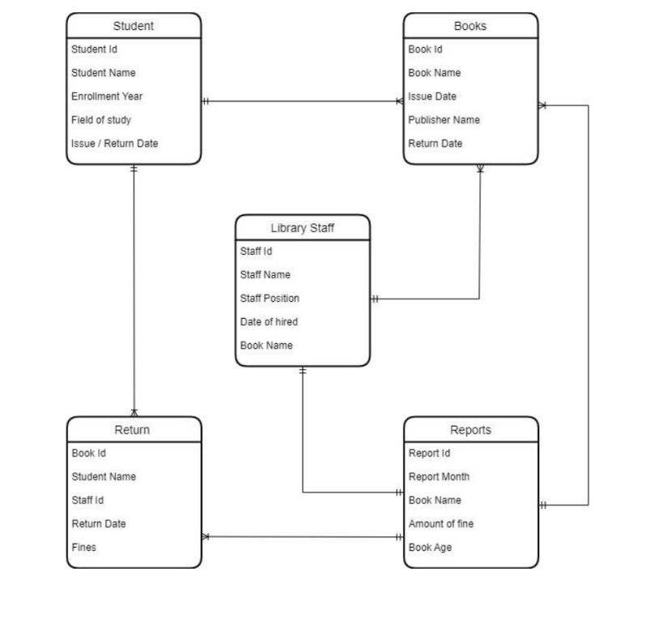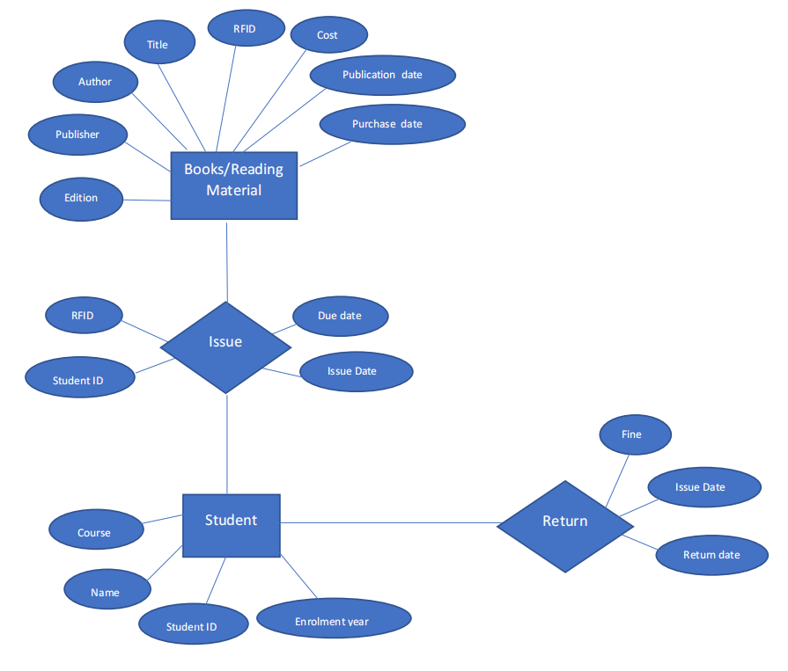

**Wire frames or Mock screens for library management system:**

